**RIPHAH INTERNATIONAL UNIVERSITY, ISLAMABAD**



**Lab 12**

**Bachelors of Computer science – 6th semester**

**Subject:** Artificial Intelligence Lab

**Submitted to:** Ma’am Ayesha

**Submitted by:** Areeba Sadaqat

**Sap Id:** 47633

**Date:** 29th April, 2025

**Question 01:**

**SVM Algorithm:**

| **ID** | **Feature 1 (X1)** | **Feature 2 (X2)** | **Label (Y)** |
| --- | --- | --- | --- |
| 1 | 2.5 | 2.4 | 0 |
| 2 | 1.0 | 1.2 | 0 |
| 3 | 2.2 | 2.9 | 0 |
| 4 | 1.3 | 1.1 | 0 |
| 5 | 3.0 | 3.0 | 0 |
| 6 | 7.6 | 8.0 | 1 |
| 7 | 6.8 | 7.1 | 1 |
| 8 | 8.2 | 8.5 | 1 |
| 9 | 7.1 | 6.5 | 1 |
| 10 | 6.5 | 7.0 | 1 |
| 11 | 3.2 | 2.9 | 0 |
| 12 | 2.8 | 2.7 | 0 |
| 13 | 7.5 | 6.9 | 1 |
| 14 | 8.0 | 8.3 | 1 |
| 15 | 1.5 | 1.0 | 0 |
| 16 | 2.0 | 2.2 | 0 |
| 17 | 6.9 | 7.4 | 1 |
| 18 | 7.2 | 6.8 | 1 |
| 19 | 3.0 | 2.6 | 0 |
| 20 | 8.3 | 8.7 | 1 |

* Load the dataset into Python from a .csv file.
* Split it into training and testing sets (70% train, 30% test).
* Train an SVM model using kernel='linear'.
* Print the accuracy on the test set.
* Plot the data and the decision boundary.

import pandas as pd

import numpy as np

import matplotlib.pyplot as plt

from sklearn.model_selection import train_test_split

from sklearn.svm import SVC

from sklearn.metrics import accuracy_score

# Load data (adjust path if needed)

df = pd.read_csv('SVM.csv')

# Print columns to confirm names (debugging tip)

print("Column names:", df.columns)

# Ensure correct column names

# You may need to adjust these if your CSV uses 'X1', 'X2', 'Y' etc.

X = df[['Feature 1 (X1)', 'Feature 2 (X2)']].values

y = df['Label (Y)'].values

# Train-test split (70% train, 30% test)

X_train, X_test, y_train, y_test = train_test_split(X, y, test_size=0.3, random_state=42)

# Train SVM with linear kernel

model = SVC(kernel='linear')

model.fit(X_train, y_train)

# Predict and calculate accuracy

y_pred = model.predict(X_test)

accuracy = accuracy_score(y_test, y_pred)

print(f"Test Accuracy: {accuracy * 100:.2f}%")

# Plotting decision boundary

def plot_decision_boundary(X, y, model):

plt.figure(figsize=(8, 6))

plt.scatter(X[:, 0], X[:, 1], c=y, cmap='bwr', s=30, edgecolors='k')

# Create mesh grid

ax = plt.gca()

xlim = ax.get_xlim()

ylim = ax.get_ylim()

xx, yy = np.meshgrid(np.linspace(xlim[0], xlim[1], 100),

np.linspace(ylim[0], ylim[1], 100))

xy = np.vstack([xx.ravel(), yy.ravel()]).T

Z = model.decision_function(xy).reshape(xx.shape)

# Plot decision boundary and margins

plt.contour(xx, yy, Z, colors='k', levels=[0], alpha=0.5, linestyles=['-'])

plt.contour(xx, yy, Z, colors='grey', levels=[-1, 1], alpha=0.3, linestyles=['--'])

plt.xlabel("Feature 1 (X1)")

plt.ylabel("Feature 2 (X2)")

plt.title("SVM Decision Boundary")

plt.show()

# Call the function to plot

plot_decision_boundary(X, y, model)

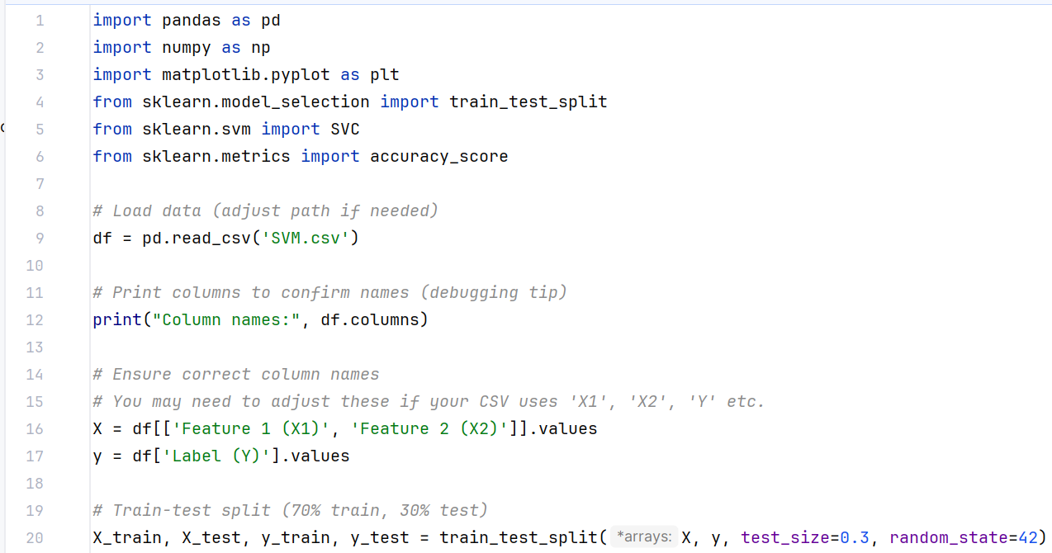

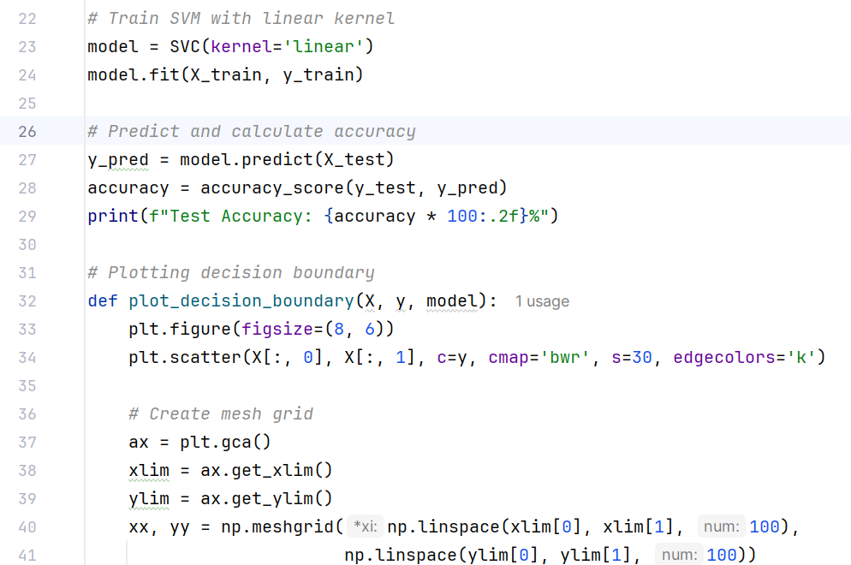

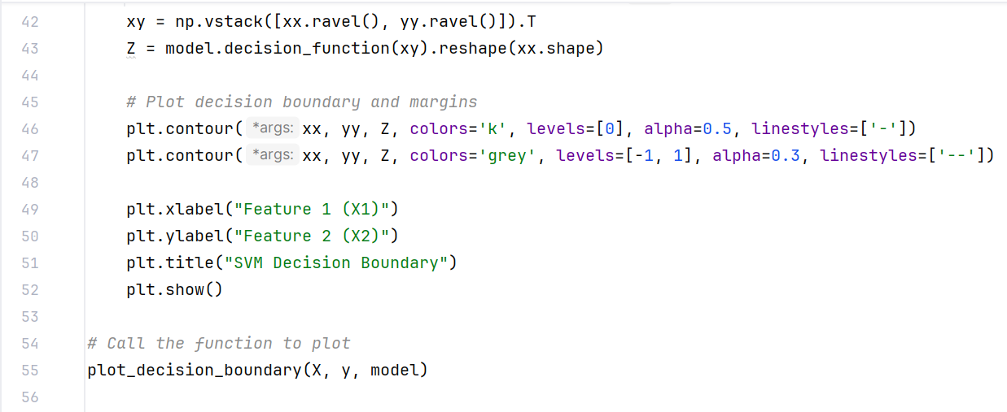

**Output:**

